DEPARTMENT OF ELECTRONICS & TELECOMMUNICATION ENGINEERING

CONTINUOUS ASSESSMENT II
CYBER SECURITY
CASE STUDY REPORT

Network Reconnaissance and Security Assessment Using Nmap: A Practical Case Study

Group Number: 36
Student 1: Akarsh Khot (PRN: 23070123012)
Student 2: Amreet Anooj (PRN: 23070123018)
Batch and Semester: 2023–2027, Semester VII
Assessment Type: Case Study

Contents
Abstract
Keywords
1. Introduction
1.1 Problem Statement
1.2 Aim and Objectives
1.3 Scope and Authorization
2. Literature Review
3. Methodology
3.1 Tools and Environment
3.2 Commands Used
4. Implementation Details
5. Results and Discussion
5.1 Firewall Profile Observation
5.2 SMB Configuration
5.3 Security Recommendations
6. Limitations
7. Conclusion
Appendix A. Evidence Files
Appendix B. Screenshot Evidence
References
References

Abstract
This case study demonstrates a small, authorized endpoint security assessment using Nmap and built-in Windows inspection tools. The objective was to identify listening TCP ports on a Windows laptop, investigate the associated processes, and review selected firewall and Server Message Block (SMB) settings. Nmap 7.992 was used against the loopback address 127.0.0.1. The initial scan reported four open TCP ports—135, 445, 1042 and 7778—and 996 closed ports among the default set of 1,000 TCP ports scanned. A focused service-detection scan identified Microsoft Windows RPC on port 135; the labels for ports 445, 1042 and 7778 were not all conclusively verified by Nmap. PowerShell linked the local listeners on ports 1042 and 7778 to ASUS-related processes and showed Windows RPC services associated with port 135. The SMB server service was running, SMB1 was disabled, SMB2 was enabled, and the standard administrative shares ADMIN$, C$ and IPC$ were listed. Firewall profiles were initially reported as Domain enabled, Private disabled and Public disabled; a later check showed all three enabled. The repeated loopback scan returned the same four open ports. These results demonstrate that a port scan is an inventory step, not proof of a vulnerability. Because the scan target was localhost, the experiment does not establish reachability from another device or from the internet.

Keywords
Nmap; network reconnaissance; TCP port scanning; service detection; Windows Firewall; SMB; endpoint security; security assessment.

1. Introduction
Network reconnaissance is the process of gathering information about systems, services and network exposure. Defenders use it to maintain an inventory, investigate unexpected listeners and verify whether configurations match policy. The same discovery techniques may also be used by attackers to locate services that could become entry points, which is why scanning should be authorized and carefully scoped [1, 4, 13, 20]. Nmap is a widely used open-source tool for host discovery and security scanning. It can classify ports by their observed response and, when requested, probe services for additional identifying information [1, 5, 7].

1.1 Problem Statement
A Windows computer may run background services for operating-system functions, device utilities and file sharing. A list of open ports alone does not explain which process owns each listener, whether the service is needed, or whether it can be reached from another device. The problem addressed in this case study is how to perform a basic, repeatable port inventory on a Windows endpoint and interpret the results alongside local process, firewall and SMB configuration evidence.

1.2 Aim and Objectives
The aim is to demonstrate a beginner-friendly, authorized Nmap-based security assessment of one Windows laptop. The objectives are: (i) scan the laptop's loopback interface for common TCP ports; (ii) save the scan output for repeatable evidence; (iii) perform light service/version detection on the discovered ports; (iv) compare Nmap results with Windows listening sockets and process/service information; (v) inspect firewall profiles, SMB protocol settings and configured SMB shares; and (vi) identify limitations and recommend proportionate defensive actions.

1.3 Scope and Authorization
Only the student’s own Windows laptop was assessed. The main Nmap target was 127.0.0.1, the loopback address that refers to the same computer. No external address, third-party host or other device was scanned. The experiment was limited to observation and configuration checks; it did not exploit services, attempt credential access, or change SMB settings. The firewall was enabled through Windows Security and the resulting profile state was verified. Nmap guidance also emphasizes understanding legal and authorization boundaries before scanning [11].

2. Literature Review
Nmap’s official guide describes port scanning as a way to determine which ports are open, closed or filtered based on responses to probes. The meaning of a port state depends on the scan method and the target’s response; it should not be interpreted as a direct vulnerability rating [1, 5, 12]. TCP connect scanning (-sT) uses the operating system’s connect call to establish TCP connections, while service detection (-sV) sends probes to identify a service and, where possible, its product or version [6, 7, 10]. Nmap’s output documentation recommends saving results in suitable formats so that findings can be reviewed and compared later [8, 9].
NIST SP 800-115 provides a structured foundation for technical security testing: plan the test, conduct it within scope, analyze results, and develop mitigation recommendations [13]. NIST SP 800-41 Rev. 1 explains that firewalls enforce traffic policies and should be configured, tested and maintained according to the system’s purpose and risk [14]. The NIST Cybersecurity Framework 2.0 organizes cybersecurity work around Govern, Identify, Protect, Detect, Respond and Recover, supporting the view that asset discovery and secure configuration are ongoing activities rather than one-time tasks [16]. CIS Controls similarly emphasize secure configuration, inventory and network infrastructure management [18, 19].
Microsoft documentation describes Windows Firewall as a host-based control that filters traffic according to rules, addresses, protocols and ports. It provides Domain, Private and Public profiles so policy can reflect the type of network connection [21, 22]. Microsoft’s PowerShell documentation defines commands used in this experiment to inspect TCP connections and network profiles [23, 24]. The SMB documentation recommends limiting unnecessary SMB exposure, inventorying shares, disabling SMB1 when not required, and applying firewall restrictions appropriate to the environment [27–29]. The presence of an SMB share or open port is not, by itself, proof of unauthorized access; permissions, authentication, firewall policy and network reachability must also be considered.
MITRE ATT&CK lists Network Service Discovery (T1046) as a technique used by adversaries to enumerate services. This illustrates why defenders should know which services are listening and monitor unexpected changes [20]. The TCP standard defines the transport protocol on which the observed TCP ports operate [30], while RFC 1918 describes private IPv4 address space used in internal networks [31]. These references support the technical interpretation of scan results but do not substitute for testing reachability from a separate host.

3. Methodology
The assessment followed a staged, non-destructive workflow aligned with common security-testing guidance [13]. First, Nmap was installed and its version was checked. Second, a TCP connect scan was run against 127.0.0.1 using -sT and -Pn. Third, normal output was saved to a text file. Fourth, a focused service-detection scan was limited to the four discovered ports using -sV and --version-light. Fifth, PowerShell was used to inspect listening sockets, owning process IDs, associated services, firewall profile state, network category, SMB server configuration and SMB shares. Finally, the scan was repeated after the firewall profiles were confirmed enabled. The procedure was limited to the local machine and did not include vulnerability exploitation or remote-host testing.

3.1 Tools and Environment
• Operating system: Microsoft Windows (the terminal identified Windows version 10.0.26200.9711). • Scanner: Nmap 7.992 for Windows. • Shell: Windows PowerShell. • Target: 127.0.0.1 (localhost). • Supporting commands: Get-NetTCPConnection, Get-Process, Get-CimInstance Win32_Service, Get-NetFirewallProfile, Get-NetConnectionProfile, Get-Service, Get-SmbServerConfiguration and Get-SmbShare. The use of native Windows commands allowed Nmap’s port observations to be compared with local system configuration [21–26].

3.2 Commands Used
Initial scan: nmap -sT -Pn 127.0.0.1
Saved initial scan: nmap -sT -Pn 127.0.0.1 -oN nmap_results.txt
Post-firewall scan: nmap -sT -Pn 127.0.0.1 -oN nmap_after_firewall.txt
Focused service scan: nmap -sT -Pn -sV --version-light -p 135,445,1042,7778 127.0.0.1 -oN nmap_service_verification.txt
The -sT option selects TCP connect scanning; -Pn skips host discovery; -sV requests service/version detection; --version-light reduces probe intensity; -p selects the specified ports; and -oN saves human-readable output [2, 6–8].

4. Implementation Details
Nmap was installed and verified by running nmap --version, which returned version 7.992. The first scan completed successfully and reported the host up. The command scanned Nmap’s default set of 1,000 common TCP ports, with 996 closed and four open. The scan output was saved to nmap_results.txt. A second scan after the firewall profile check was saved to nmap_after_firewall.txt. A focused service scan was saved to nmap_service_verification.txt. These files were later confirmed to exist in the user folder before being moved to the project folder.
PowerShell inspection showed listeners on port 135 at wildcard IPv4 and IPv6 addresses, port 445 at the IPv6 wildcard address, and ports 1042 and 7778 at 127.0.0.1. The process IDs shown were 1788 for port 135, 4 for port 445, 5104 for port 1042 and 6172 for port 7778. Process inspection identified PID 1788 as svchost.exe, PID 5104 as asus_framework.exe and PID 6172 as ArmouryCrateControlInterface.exe. The service query associated PID 1788 with RpcEptMapper and RpcSs, and PID 6172 with ArmouryCrateControlInterface. PID 4 was shown as System; this report does not claim that this alone proves remote SMB accessibility.

5. Results and Discussion
Table 1 summarizes the initial Nmap scan. The service labels in Nmap’s standard output may be based on the port-number database unless service detection confirms the protocol. Nmap’s own documentation notes that service/version detection may fail to identify a service conclusively [7, 9].

Table 1. Initial localhost scan
Item | Observed result
Target | 127.0.0.1 (localhost)
Nmap version | 7.992
Host status | Up
Scan duration | Approximately 0.26 seconds
Open TCP ports | 4
Closed TCP ports | 996 of the default 1,000 scanned

Table 2. Port-level findings
Port | Nmap result | Local evidence / interpretation
135/tcp | Open; Microsoft Windows RPC identified | PID 1788 svchost.exe; RpcEptMapper and RpcSs
445/tcp | Open; microsoft-ds? (uncertain) | PID 4 System; Server service running; SMB1 off, SMB2 on
1042/tcp | Open; afrog? / fingerprint unrecognized | PID 5104 asus_framework.exe; bound to 127.0.0.1
7778/tcp | Open; interwise? (uncertain) | PID 6172 ArmouryCrateControlInterface.exe; bound to 127.0.0.1

5.1 Firewall Profile Observation
The initial PowerShell output showed Domain=True, Private=False and Public=False. The Wi-Fi network category was reported as Public. After the user enabled the firewall through Windows Security, a later Get-NetFirewallProfile query showed Domain=True, Private=True and Public=True. This verifies the later profile configuration. The localhost scan still showed the same four open ports. This is expected to be possible because localhost scans test listeners on the same computer and do not establish whether a remote host can connect through the network interface. Therefore, the before/after result does not prove that the firewall failed; it demonstrates that the experiment’s target and scope matter [14, 21, 22].

5.2 SMB Configuration
The Get-Service LanmanServer command returned Running. Get-SmbServerConfiguration returned EnableSMB1Protocol=False and EnableSMB2Protocol=True. Get-SmbShare listed ADMIN$, C$ and IPC$. These are common Windows administrative or communication shares. Their presence is not automatically a vulnerability. A proper exposure assessment would require checking relevant inbound firewall rules, access permissions and reachability from an authorized second host. Since no second device was available, remote reachability was outside this case study’s scope [27–29].

5.3 Security Recommendations
1. Keep Windows Firewall enabled for the applicable network profiles and review rules that allow inbound traffic [14, 21, 22].
2. Keep SMB1 disabled unless a documented legacy requirement exists; maintain SMB2/SMB3 with current security updates [28, 29].
3. Review whether SMB server functionality and administrative shares are needed for the laptop’s intended use. Do not remove or disable them blindly; first check dependencies and administrative requirements [25–29].
4. Review the ASUS-related listeners (ports 1042 and 7778) through installed-app documentation and vendor support. Since the listeners were bound to 127.0.0.1, avoid describing them as network-exposed based only on this test.
5. Repeat the scan after software or configuration changes and compare saved output files. Keep a record of the date, target, command, results and limitations [1, 8, 13].
6. Only scan systems for which explicit authorization exists. The present test was restricted to the student’s own laptop [11, 13].

6. Limitations
The main limitation is that every Nmap scan targeted 127.0.0.1. A loopback scan reveals services reachable through the local loopback interface, not necessarily services reachable from other computers. No second computer was available to conduct a controlled remote test. Nmap did not conclusively identify the services on ports 1042 and 7778, and the service label for port 445 included a question mark. The assessment did not run a vulnerability scan, test credentials, inspect every firewall rule, or test the router. Findings should therefore be treated as a local inventory and configuration review rather than a complete penetration test or proof of exploitable vulnerabilities.

7. Conclusion
This case study demonstrated a basic and repeatable Nmap workflow on a Windows laptop. The initial scan found four open TCP ports on localhost. Service detection confirmed Windows RPC on port 135 but did not conclusively identify every other service. PowerShell connected several listeners to Windows RPC and ASUS-related processes, while SMB checks showed SMB1 disabled, SMB2 enabled and three standard shares. Firewall profiles were subsequently verified as enabled, and the repeated localhost scan returned the same ports. The key lesson is that open ports must be interpreted alongside process identity, configuration, firewall policy and test scope. The results provide a foundation for a more complete assessment, but remote reachability remains untested.

Appendix A. Evidence Files
The following evidence files were created during the practical work and confirmed to exist: nmap_results.txt (initial scan), nmap_after_firewall.txt (repeat scan after firewall configuration), and nmap_service_verification.txt (focused service-detection scan). The user also captured terminal screenshots in the conversation. Before final submission, insert the original screenshots into the report if required by the instructor and retain the three text outputs in the methodology/project ZIP. Do not fabricate or edit scan results.

References
Accessed 16 October 2026. Online documentation may be updated by the publishers.
[1] Lyon, G. F. (2009–2022). Nmap Network Scanning: The Official Nmap Project Guide to Network Discovery and Security Scanning. Nmap Project. https://nmap.org/book/
[2] Nmap Project. (n.d.). Nmap Reference Guide / Manual Pages. https://nmap.org/book/man.html
[3] Nmap Project. (n.d.). Installing Nmap on Windows. https://nmap.org/book/inst-windows.html
[4] Nmap Project. (n.d.). Host Discovery (“Ping Scanning”). Nmap Network Scanning. https://nmap.org/book/host-discovery.html
[5] Nmap Project. (n.d.). Port Scanning Basics. Nmap Reference Guide. https://nmap.org/book/man-port-scanning-basics.html
[6] Nmap Project. (n.d.). TCP Connect Scan (-sT). Nmap Network Scanning. https://nmap.org/book/scan-methods-connect-scan.html
[7] Nmap Project. (n.d.). Service and Version Detection (-sV). Nmap Network Scanning. https://nmap.org/book/man-version-detection.html
[8] Nmap Project. (n.d.). Output Formats. Nmap Reference Guide. https://nmap.org/book/man-output.html
[9] Nmap Project. (n.d.). XML Output. Nmap Network Scanning. https://nmap.org/book/output-formats-xml-output.html
[10] Nmap Project. (n.d.). Service and Application Version Detection. Nmap Network Scanning. https://nmap.org/book/vscan.html
[11] Nmap Project. (n.d.). Legal Issues. Nmap Network Scanning. https://nmap.org/book/legal-issues.html
[12] Nmap Project. (n.d.). The Phases of an Nmap Scan. Nmap Network Scanning. https://nmap.org/book/nmap-phases.html
[13] Souppaya, M., Scarfone, K., Cody, A., & Orebaugh, A. (2008). Technical Guide to Information Security Testing and Assessment (NIST SP 800-115). NIST. https://doi.org/10.6028/NIST.SP.800-115
[14] Scarfone, K., & Hoffman, P. (2009). Guidelines on Firewalls and Firewall Policy (NIST SP 800-41 Rev. 1). NIST. https://doi.org/10.6028/NIST.SP.800-41r1
[15] Joint Task Force. (2020, updated). Security and Privacy Controls for Information Systems and Organizations (NIST SP 800-53 Rev. 5). NIST. https://doi.org/10.6028/NIST.SP.800-53r5
[16] National Institute of Standards and Technology. (2024). The NIST Cybersecurity Framework (CSF) 2.0. https://doi.org/10.6028/NIST.CSWP.29
[17] Cybersecurity and Infrastructure Security Agency. (2023). Cross-Sector Cybersecurity Performance Goals. https://www.cisa.gov/cross-sector-cybersecurity-performance-goals
[18] Center for Internet Security. (n.d.). CIS Critical Security Controls v8.1: Control 4—Secure Configuration of Enterprise Assets and Software. https://www.cisecurity.org/controls/secure-configuration-of-enterprise-assets-and-software
[19] Center for Internet Security. (n.d.). CIS Critical Security Controls: Control 12—Network Infrastructure Management. https://www.cisecurity.org/controls/network-infrastructure-management
[20] MITRE ATT&CK. (n.d.). Network Service Discovery (T1046). https://attack.mitre.org/techniques/T1046/
[21] Microsoft. (n.d.). Windows Firewall Overview. https://learn.microsoft.com/en-us/windows/security/operating-system-security/network-security/windows-firewall/
[22] Microsoft. (n.d.). Get-NetFirewallProfile (NetSecurity). Microsoft Learn. https://learn.microsoft.com/en-us/powershell/module/netsecurity/get-netfirewallprofile
[23] Microsoft. (n.d.). Get-NetTCPConnection (NetTCPIP). Microsoft Learn. https://learn.microsoft.com/en-us/powershell/module/nettcpip/get-nettcpconnection
[24] Microsoft. (n.d.). Get-NetConnectionProfile (NetConnection). Microsoft Learn. https://learn.microsoft.com/en-us/powershell/module/netconnection/get-netconnectionprofile
[25] Microsoft. (n.d.). Get-SmbShare (SmbShare). Microsoft Learn. https://learn.microsoft.com/en-us/powershell/module/smbshare/get-smbshare
[26] Microsoft. (n.d.). Get-SmbServerConfiguration (SmbShare). Microsoft Learn. https://learn.microsoft.com/en-us/powershell/module/smbshare/get-smbserverconfiguration
[27] Microsoft. (n.d.). Secure SMB Traffic in Windows Server. https://learn.microsoft.com/en-us/windows-server/storage/file-server/smb-secure-traffic
[28] Microsoft. (n.d.). SMB Security Hardening in Windows Server and Windows Client. https://learn.microsoft.com/en-us/windows-server/storage/file-server/smb-security-hardening
[29] Microsoft. (n.d.). Detect, Enable, and Disable SMBv1, SMBv2, and SMBv3 in Windows. https://learn.microsoft.com/en-us/windows-server/storage/file-server/troubleshoot/detect-enable-and-disable-smbv1-v2-v3
[30] Eddy, W. (Ed.). (2022). Transmission Control Protocol (TCP) (RFC 9293). RFC Editor / IETF. https://www.rfc-editor.org/rfc/rfc9293
[31] Rekhter, Y., Moskowitz, B., Karrenberg, D., de Groot, G. J., & Lear, E. (1996). Address Allocation for Private Internets (RFC 1918). RFC Editor / IETF. https://www.rfc-editor.org/rfc/rfc1918
[32] Braden, R. (Ed.). (1989). Requirements for Internet Hosts—Communication Layers (RFC 1122). RFC Editor / IETF. https://www.rfc-editor.org/rfc/rfc1122

Appendix B. Screenshot Evidence
The following figures document commands and outputs captured during the practical assessment. They support the results discussed in the report. Interpretation is limited to the local machine and the commands shown; a localhost scan does not establish remote network accessibility.
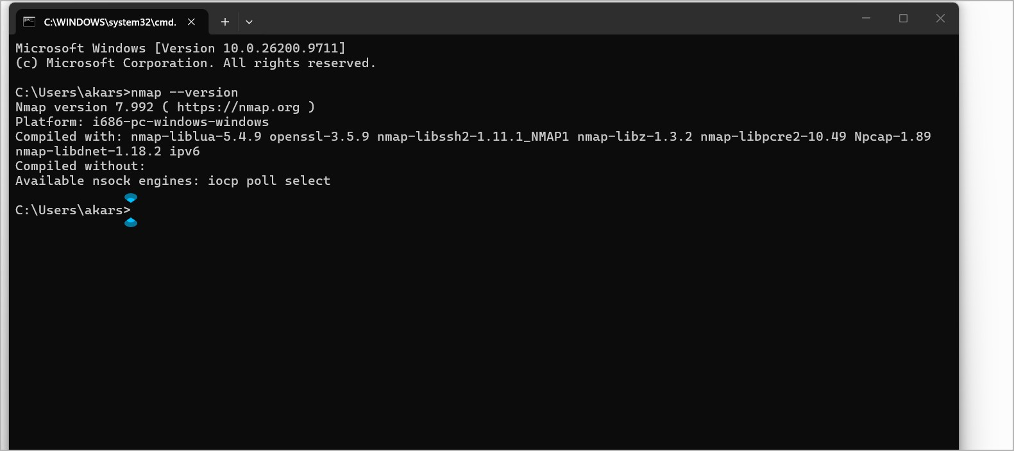
Figure B1. Nmap installation verified; the terminal reports Nmap version 7.992.
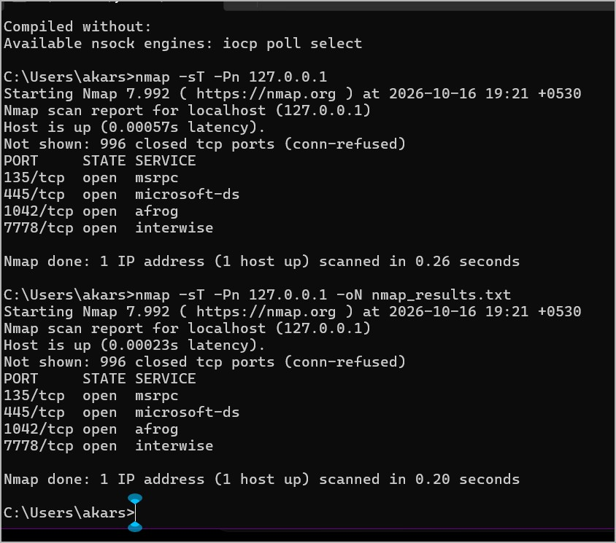
Figure B2. Initial TCP connect scan of 127.0.0.1, showing four open TCP ports.

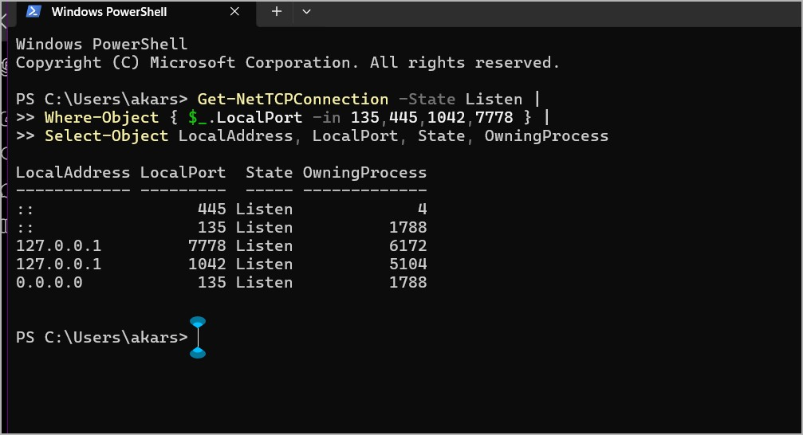
Figure B3. PowerShell inspection of listening TCP ports and their associated process IDs.
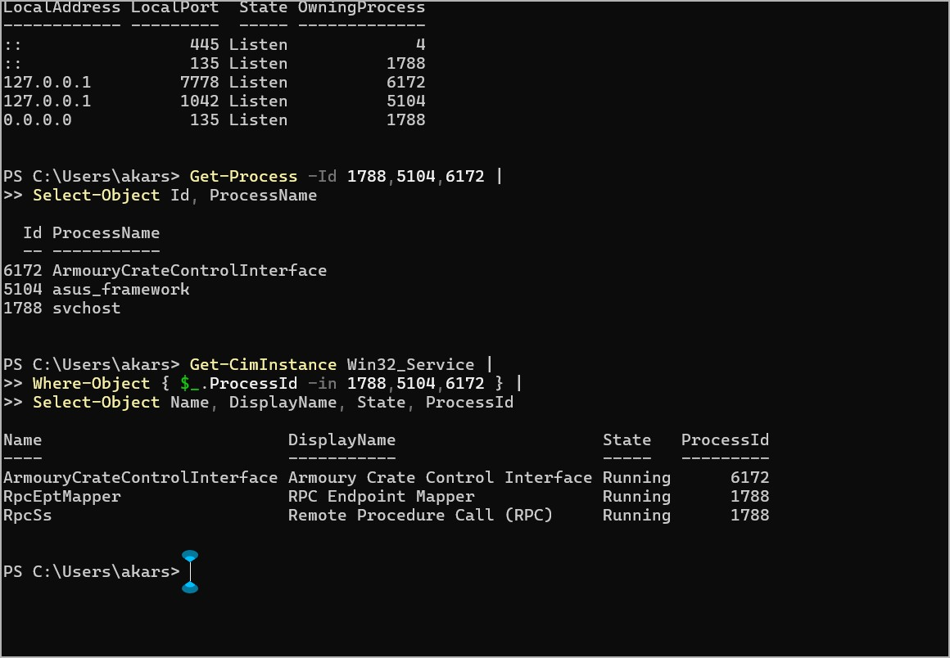
Figure B4. Process/service identification and the initial firewall-profile status.

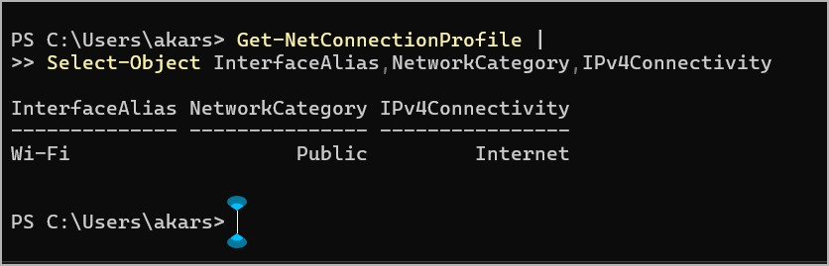
Figure B5. Windows Security overview, including a separate warning about potentially unwanted app blocking.
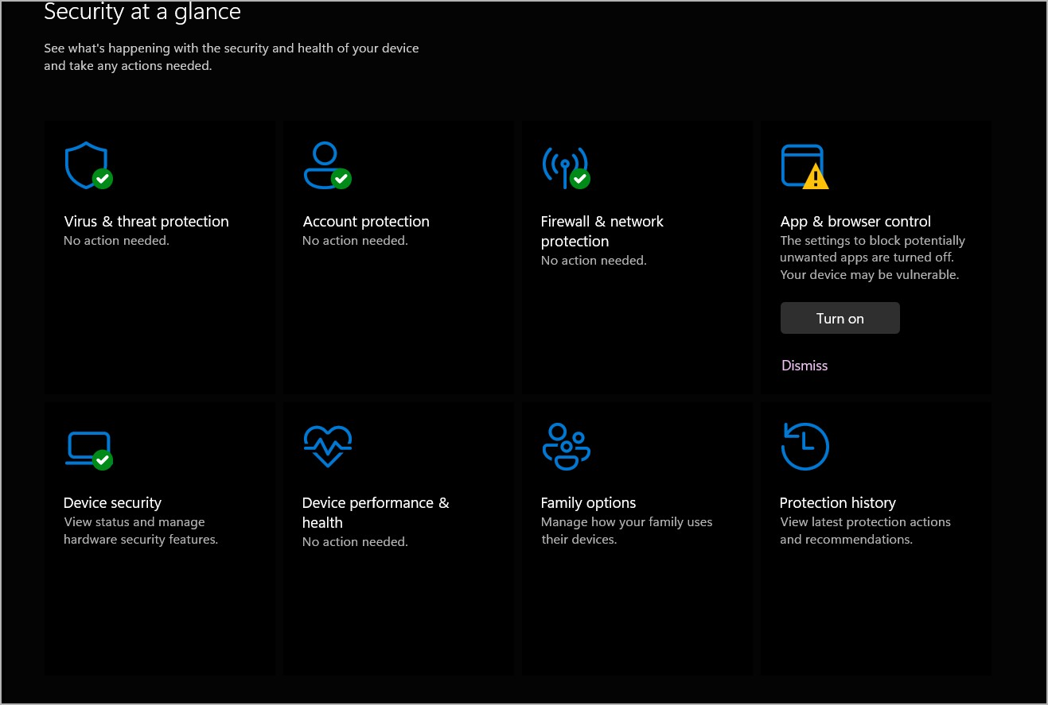
Figure B6. Firewall profiles enabled after configuration and repeat localhost scan showing the same four open ports.

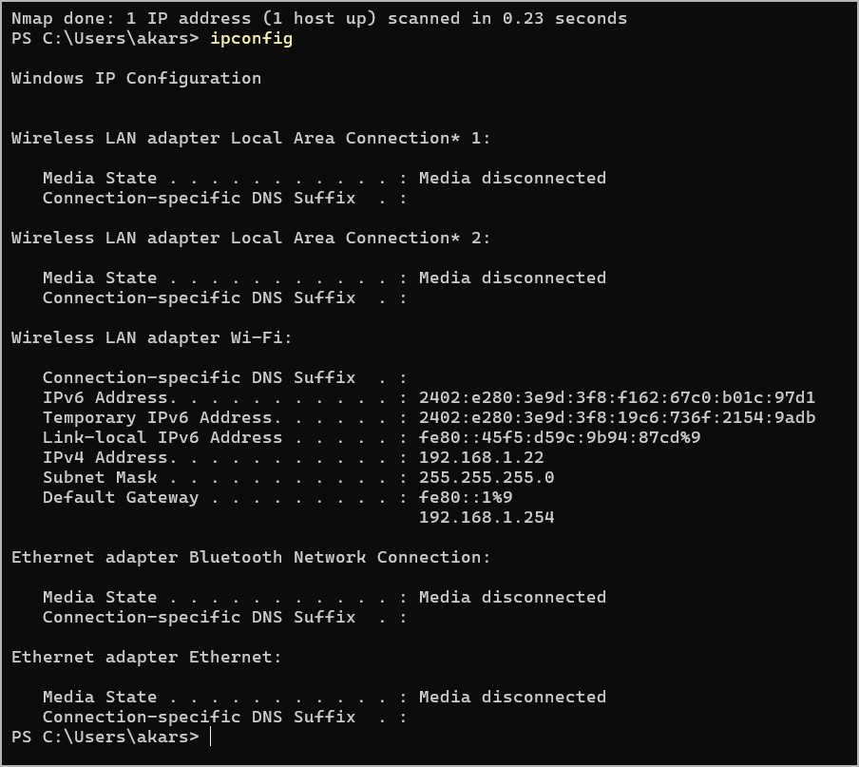
Figure B7. Focused Nmap service/version detection and SMB protocol configuration results.
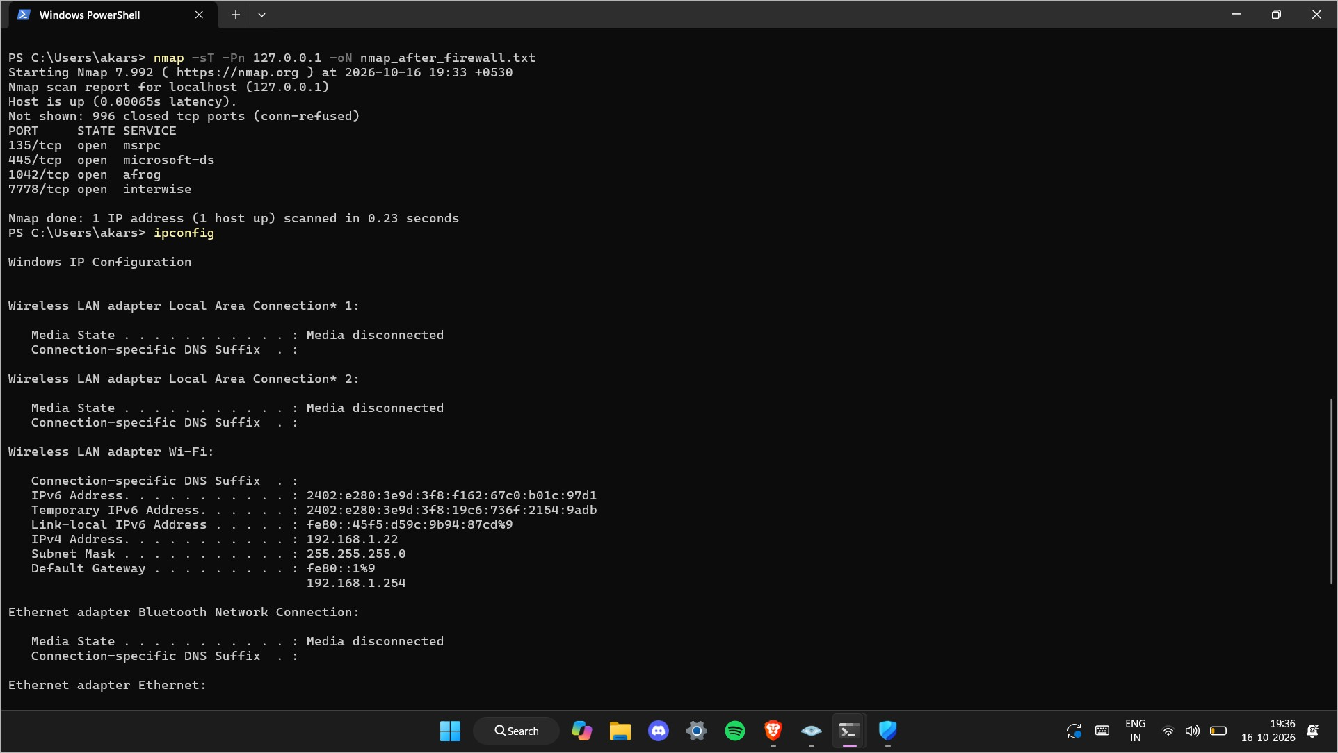
Figure B8. Windows SMB shares listed by PowerShell: ADMIN$, C$ and IPC$.

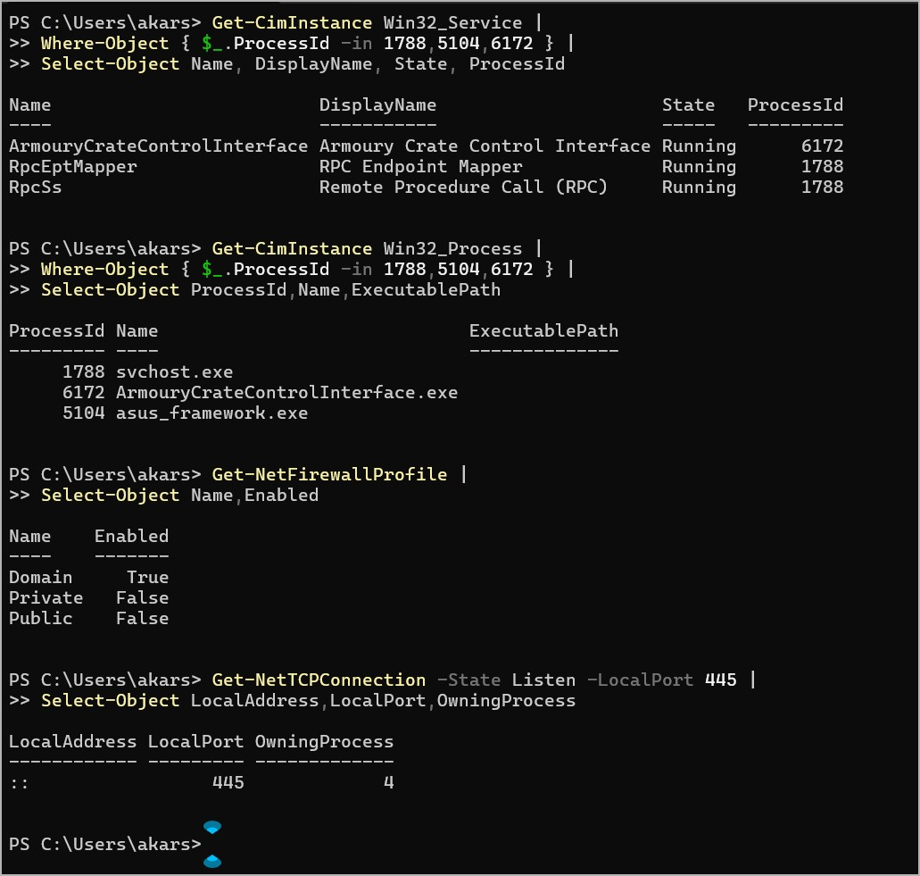
Figure B9. Wi-Fi connection profile classified as Public, with IPv4 Internet connectivity.
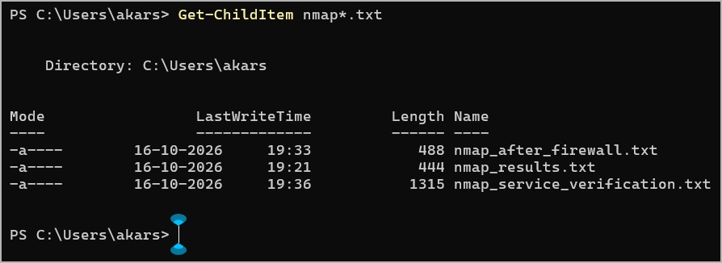
Figure B10. Confirmation that the three Nmap text-output evidence files were saved.

